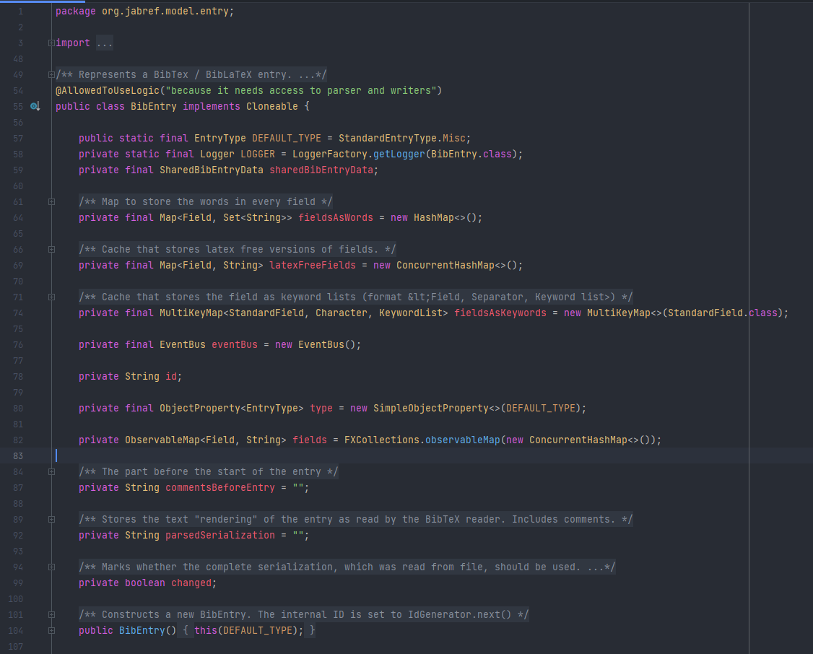

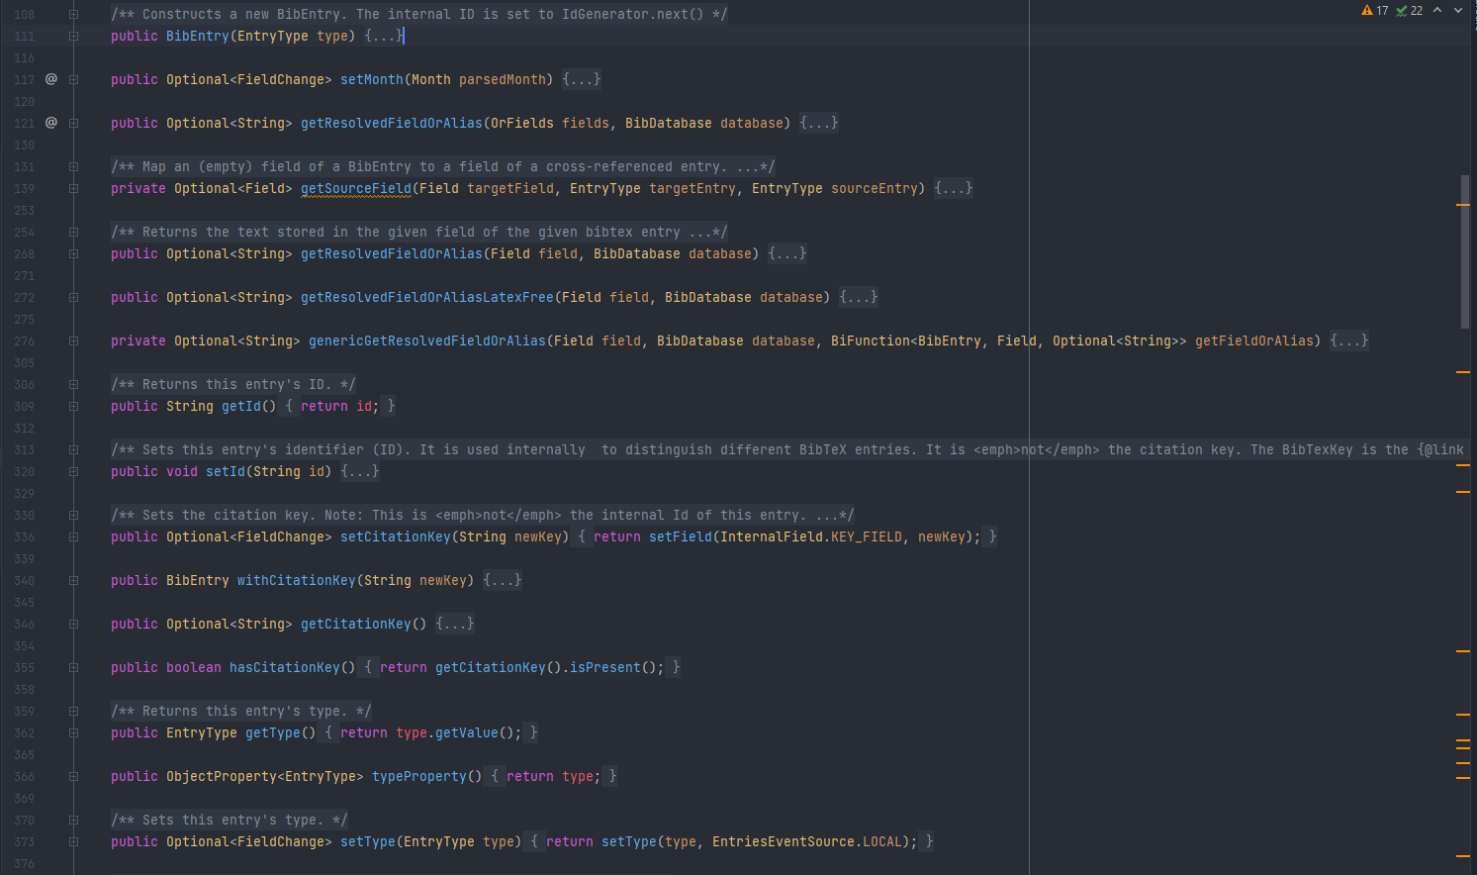

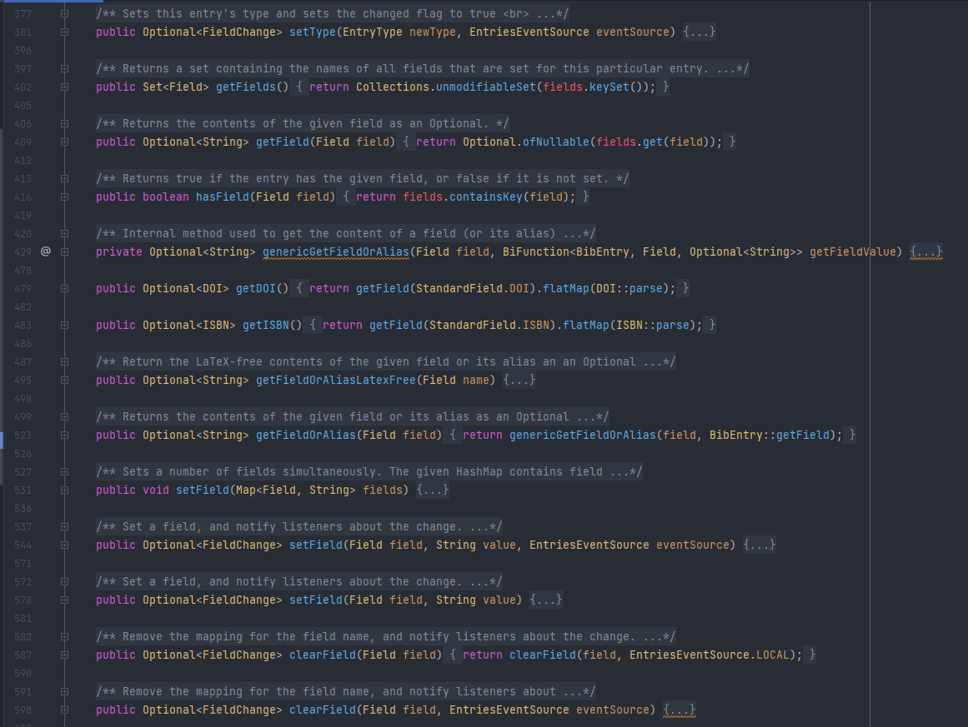

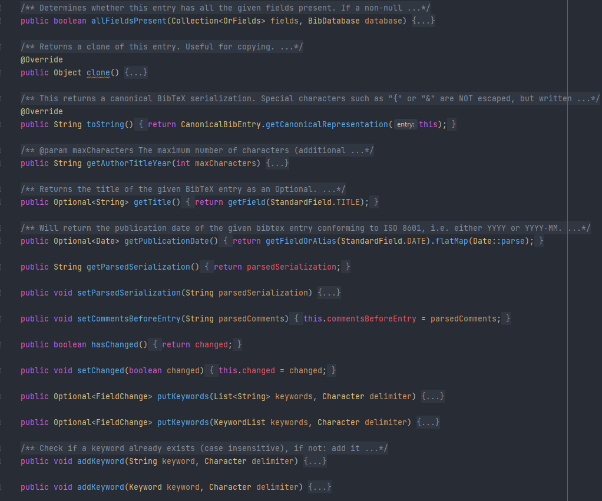

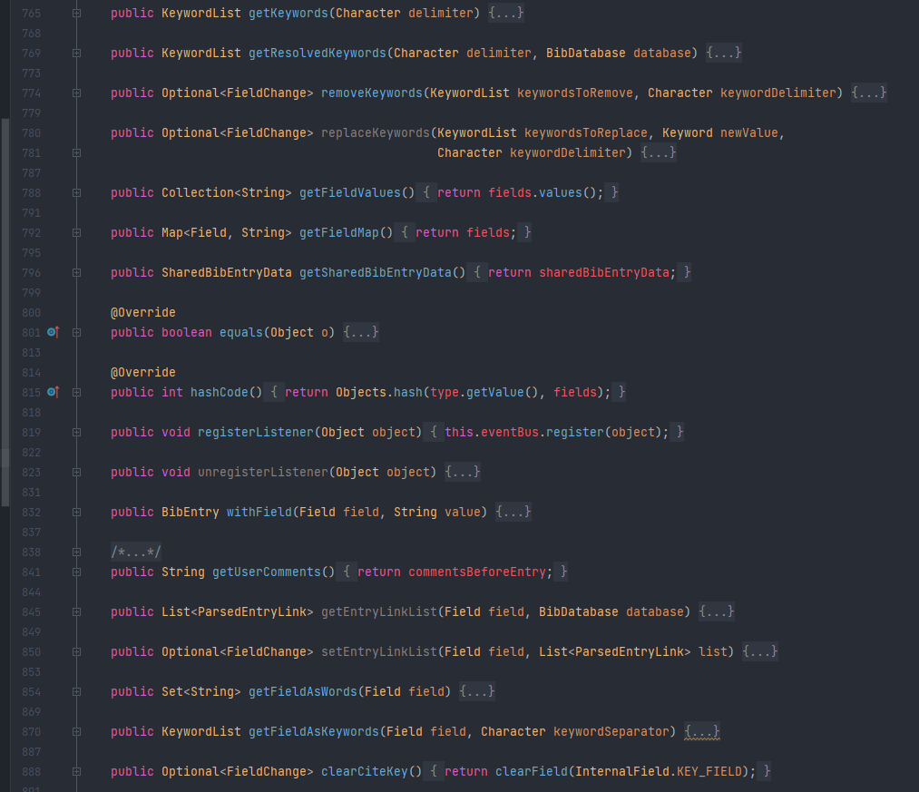

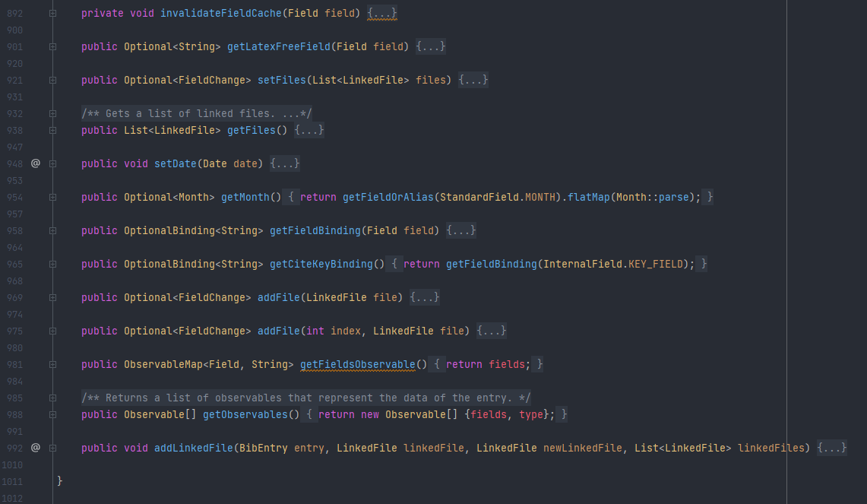

src/main/java/org/jabref/model/entry/BibEntry.java

The code smell identified in this class is Large Class, we can check that the class has more than 1000 lines of code, maybe we can divide the responsibility of this class into other classes trying to decrease the number of methods and lines.

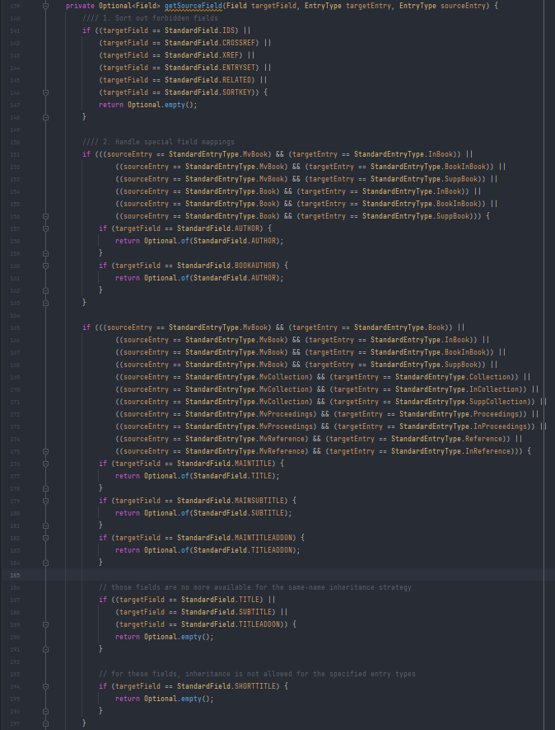

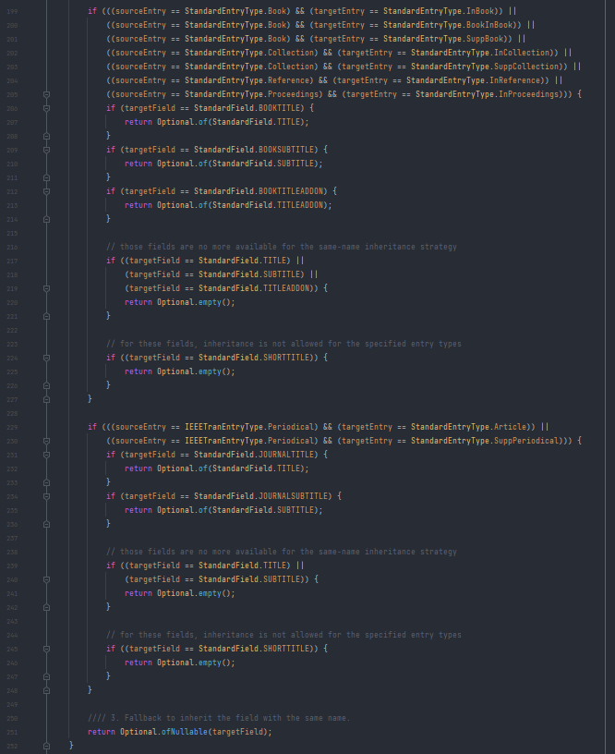

src/main/java/org/jabref/model/entry/BibEntry.java

We can check that the code smells in this code is the long method, we can check that there are parts in the method which are very similar, the logic behind it is a little confusing the first time we see the code. We should divide the method into other methods making more readable and possibly refactoring the method by not using duplicated/ similar code.

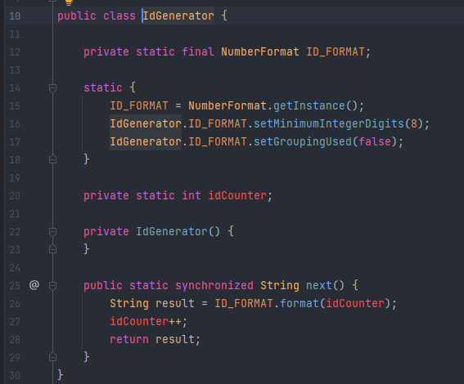

src/main/java/org/jabref/model/entry/IdGenerator.java

The code smell where is Data Class, because this class only stores the information about the id. This class could be removed if we had and ID in the upper-level Class where the Id is needed and instead of making a class for it, generate the value and store in the upper-level.